Rich Dad Poor Dad

Robert T. Kiyosaki

# It was 20 Years Ago Today (20 Years… 20/20 Hindsight)

* **Rich Dad’s Lesson #1: “The rich don’t work for money”**
  + Today, people are very aware of the growing divide between the rich and everyone else
  + Between 1993-2010: Over 50% of the increase in the national income in the US went to the wealthiest 1%
  + Between 2009-2012: 95% of the income gains also went to the wealthiest 1%
  + *The increases in income are going to entrepreneurs and investors, not to employees – not to people who work for money*
* **Rich Dad Lesson: “Savers are Losers.”**
  + For the poor and middle class, “saving money” is a religion, financial salvation from poverty and protection from the cruel world
  + Take a look at the chart of 120 years of Dow Jones Industrial Average: there have been three massive stock market crashes in the first 10 years of this new century
    - The dotcom crash around the year 2000
    - The real estate crash of 2007
    - The banking crash of 2008

…

* + If you compare that to the giant crash of 1929, you get a better idea of just how massive those crashes were

...

* + After each crash, the U.S. government and federal reserve bank began “printing money”
  + Banks cut interest rates and printed money, leaders want us to believe they were saving the world, but the rich were saving themselves and threw the poor and middle class under the bus
  + “Today interest rates in many countries are below zero, which is why savers are losers.”
* **Rich Dad Lesson: “Your house is not an asset.”**
  + This lesson was heavily criticized when he first tried to publish the book in 1997
  + Ten years later, in 2007, subprime borrowers began to default on their subprime mortgages, the real estate bubble burst and millions of homeowners found out the truth the hard way
  + The real estate crash was not really a real estate crash, it was caused by the rich, not the poor
  + The rich created financially-engineered products known as **derivatives** (“weapons of mass financial destruction” according to Warren Buffett)
    - … look up derivatives …
  + When these weapons started to explode, the real estate market crashed, and poor, subprime borrowers were blamed
  + In 2007, there was an estimated $700 trillion in financial derivatives
  + Today, there are $1.2 quadrillion in financial derivatives. In other words, the real problem has gotten bigger, not better
  + From page 13: Not only does your personal residence not put money in your pocket, but you cannot count on the fact that it will go up in value. Many houses in 2017 are still worth less than they were in 2007
* **Rich Dad Lesson: “Why the rich pay less in taxes.”**
  + In the 2007 presidential elections, when it was disclosed that incumbent Barack Obama pays about 30% of his income in taxes and Governor Mitt Romney paid less than 13% in taxes, Mitt Romney began the downhill slide that would cost him the election
  + Rather than find out how Mitt Romney and Donald Trump pay less in taxes *legally*, the poor and middle class get angry
  + Even if taxes are reduced on the poor and middle class, the rich will always pay less taxes
    - The reason for this is lesson 1: “The rich don’t work for money”. As long as someone works for money, they will pay taxes.
  + Even when Hillary Clinton was promising to raise the taxes on the rich, she was promising to raise the taxes on those with high incomes – doctors, actors, and lawyers – not the real rich
* ***Why the Rich are Getting Richer* is similar to this book but at a higher and more in-depth level**

# Introduction

* One of the reasons the rich get rich, the poor get poor, and the middle class struggles in debt is that the subject of money is taught at home, not in school.
* Most of us learn from our parents, but what can poor parents tell their child about money? They just say “stay in school and study hard.”
  + So the kid may graduate with excellent grades, but with a poor person’s financial programming and mindset
* Money is not taught in schools, so you have politicians and government officials making decisions with little or no training in the subject of money (hence the staggering national debt)
* You might say “I can’t afford it” but it would be better to ask “How can I afford it?”
  + One is a statement, and the other a question
  + One lets you off the hook, and the other forces you to think
  + The former is mental laziness, the latter puts your brain to work
* Many people put their brains to sleep when it comes to finances
  + Exercise your brain instead, you will get stronger financially in the long term
* **Read Pages 13-14**
* “There is a difference between being poor and being broke. Broke is temporary. Poor is eternal.”
* He includes Robert Frost’s “The Road Not Taken”
* **Money is a form of power. But what is more powerful is financial education.**
  + Money comes and goes, but if you have the education about how money works, you fain power over it and can begin building wealth
* There are six lessons that rich dad taught him and that we go over in this book.

# Chapter One

## Lesson 1: The Rich Don’t Work for Money

*The poor and the middle-class work for money. The rich have money work for them.*

* He tells the story of his partnership at nine years old with his friend Mike and how they both went to Mike’s dad for advice on becoming rich
* Mike’s dad is the one Kiyosaki refers to as his rich dad
  + He made them both work 3 hours every Saturday for 10 cents an hour (the minimum wage then was 25 cents/hour I think)
* The world is moving faster and faster, stock market trades are made in milliseconds, deals come and go on the Internet in minutes
  + **The faster you can make a decision the more likely you’ll be able to seize opportunities – before someone else does**
  + Take it or leave it
* Edgar Dale helped show that we learn best through action – doing the real thing or a simulation
  + Reading and lecture are the least effective ways to learn, yet that’s how most schools teach

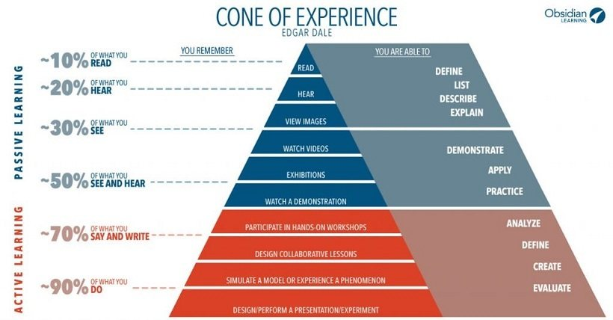

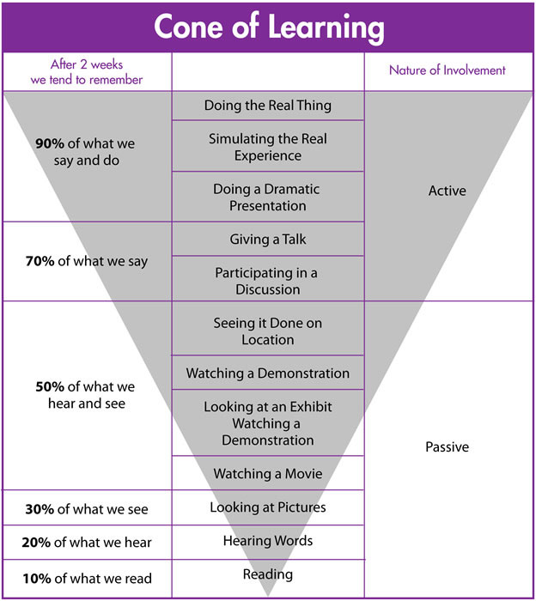

* Life pushes you around, you need to learn that lesson and move on
* Some people get pushed around, get angry and push back, they get angry at their boss, their job, their husband or wife, not knowing that it’s life that’s pushing
* If you’re the kind of person who has no guts, you just give up every time life pushes you. You’ll live all your life playing it safe, doing the right things, saving yourself for some event that never happens.
  + When you die, you’ll have lots of friends who really like you because you were such a nice and hardworking guy, but the truth is you let life push you into submission, deep down you were terrified of taking risks.
  + You really wanted to win, but the fear of losing was greater than the excitement of winning.
  + Deep inside, you and only you will know you didn’t go for it. You chose to play it safe.
* Those who learn and accept that life pushes you around welcome it, it means they need or want to learn something. They learn the lesson and move on
* Rich Dad had 150 employees, none ever asked him to teach them how to make money. Just a job and a paycheck.
  + So they don’t understand money, they just spend the best years of their lives working for it
* “Stop blaming me and thinking I’m the problem. If you think I’m the problem, then you have to change me. If you realize that you’re the problem, then you can change yourself, learn something, and grow wiser”
  + Most people want the whole world to change but them. It’s easier to change yourself than everyone else.
* Most people will quit, and go looking for another job, a better opportunity, and higher pay. Actually thinking this will solve the problem. In most cases, it won’t.
* Buying or building assets that deliver cash flow is putting your money to work for you
  + High-paying jobs mean two things: you’re working for money and the taxes you pay will probably increase
  + Put your money to work and generate income that doesn’t come from a paycheck
* **What makes the difference is the stuff between your ears. Your brain and ability to think is what will separate you from the rest.**
* True learning takes energy, passion, and a burning desire. Anger is a b ig part of that formula. Passion is anger and love combined
* When it comes to money, most people want to play it safe and feel secure. Passion does not direct them, fear does.
* Rich Dad didn’t exploit his employees. “The people exploit themselves. It’s their fear, not mine (that leads them to accept a low paycheck).
* Most people don’t want to learn because it’s easier to learn to work for money, especially if fear is the primary emotion involved
* It’s fear that keeps most people working at a j ob
  + The fear of not paying their bills, the fear of being fired, the fear of not having enough money, the fear of starting over
  + That’s the price of studying to learn a profession or trade, and then working for money. Most people become a lsave to money – and t hen get angry at their boss.”
* Most people go to college for four years, and their education ends
  + Most people never study the subject of money. They go to work, get their paycheck, balance their checkbooks, and that’s it
  + The lack of financial education is the problem
* After having worked for 10 cents an hour, three hours every Saturday, Robert when to Mike’s Dad and got the lesson above. Mike’s Dad then sent him back to work for free. Robert had to use his head to find out how to make money.

### Avoiding one of Life’s Biggest Traps

* Most people work very hard for little money, clinging to the illusion of job security and looking forward to a three-week vacation each year and a skimpy pension after forty-five years of service
* After three weeks of working for free, Mike’s Dad went to Mike and Robert to teach them. He offered them $0.25/hour, then $1/hour, then $2/hour
  + **Every person has a weak and needy part of their sould that can be bought, and he knew that every individual also had a part of their soul that was resilient and could never be bought.** **It’s only a question of which one is stronger.**
* When Mike’s dad offered them $5/hour, more than most grown ups made back then, the offer hadgotten too ridiculous, the unbuyable part took over and they refused.
* ***People’s lives are forever controlled by two emotions: fear and greed.***
* People have a price because of human emotion:
  + The fear of being without money motivates us to work hard
  + Once we get the payched, greed or desire starts us thinking about all the wonderful things money can buy
* It’s a pattern: get up, go to work, pay bills. Offer people more money and they continue the cycle by increasing their spending.
  + The Rat Race
* The first step is to *tell the truth*: Most people don’t confront their fear of not having money logically.
  + They react emotionally instead of using their heads. Then they get a few bucks in their hands and the emotions of joy, desire, and greed take over again. They react again instead of think.

…

…

…

## Lesson 2: Why Teach Financial Literacy

*It’s not how much money you make. It’s how much money you keep.*

* Assets can become large enough to grow themselves. Like a tree that you water for years and then becomes independent enough. And just provides you with shade.
* We live in a world of greater and faster change than ever before. There will be more frequent booms and busts.